# Day-70

# Polymorphism

## **Code**

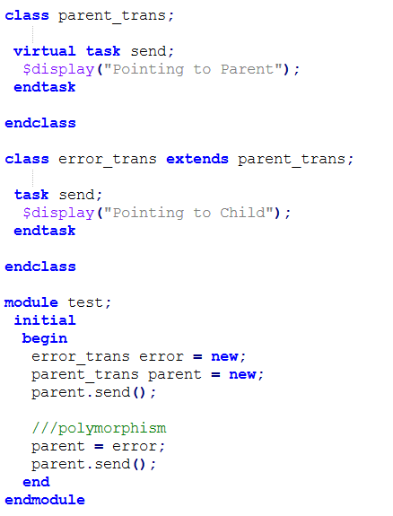

## **Simulation results**

